**📄 Retail Supply Chain Sales Analysis Report**

**Executive Summary**

This project focuses on analyzing retail supply chain sales and returns data.  
Using Excel Pivot Tables, DAX Calculations, Power Query and Power Pivot, we explored profitability, shipping costs, return behavior, customer patterns, and seasonal trends.  
The analysis provides insights that can drive smarter decision-making regarding marketing strategies, operational improvements, and profit optimization.

**Project Scope**

* Evaluate net profitability and cost efficiency across categories, regions, and customer segments.
* Analyze the impact of shipping costs on revenue and profits.
* Investigate product return patterns and customer return behavior.
* Explore customer value contribution and identify top-performing customers.
* Identify time-based trends in returns, sales, and profitability.

**Data Specifications**

* Order Table
* Return Table
* People Table
* Shipping Cost Table

**💰 Sales & Profitability**

**1.** Which product categories bring in the highest sales and profit?

**Finding:**  
Technology generates the highest Sales and profit.

2. Which regions or states generate the most profit (after returns)? Top 5

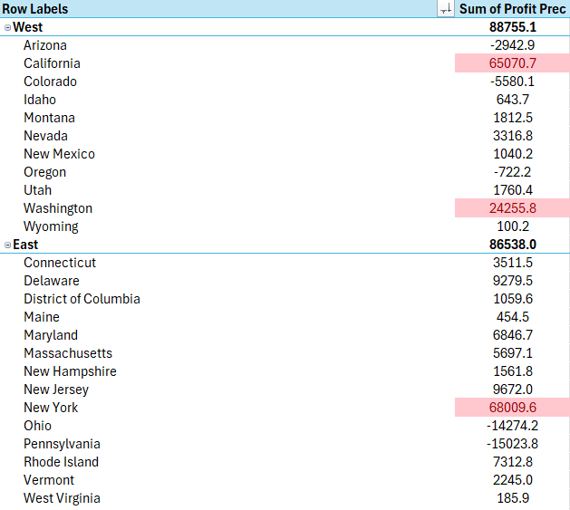

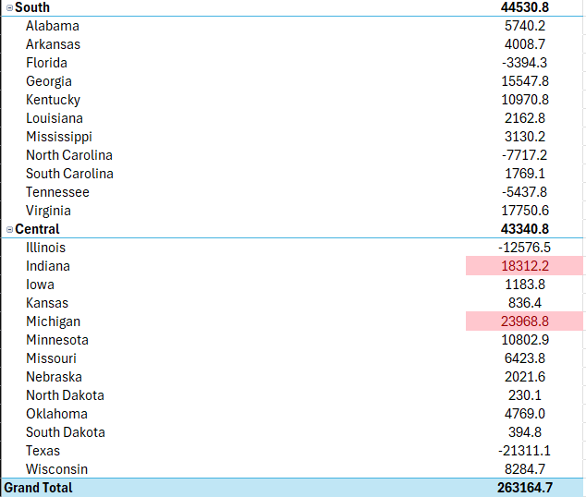

**Finding:**  
The West and East regions show the strongest profit performance. New York, California, Washington, Michigan and Indiana have the highest profit over all cities.

**3. What is the profit margin across different segments (Consumer, Corporate, Home Office)? After returns**

**Finding:**  
Home Office customers have the highest profit margins compared to other segments.

**4. What is the ROI per category or region? After returns**

**Finding:**  
Technology products and the West region show the best ROI (Return on Investment).

**🚚 Shipping & Cost Analysis**

**5. Which categories or customer types have high shipping cost per order? After returns**

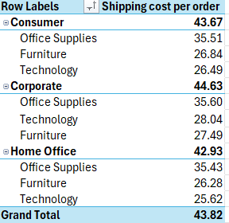

**Finding:**  
Office Supplies category has the highest average shipping cost per order.

**6. How much of my revenue goes to shipping? (Shipping Cost % of Net Revenue)**

**Finding:**  
Shipping costs represent approximately **0.11%** of the total net revenue.

**7. What is the average total cost per order across different categories?**

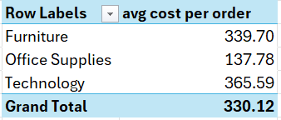

**Finding:**  
Technology has the highest total cost per order, influenced by high shipping expenses.

**🔁 Returns Insight**

**8. What is the return rate by category, region, or customer segment?**

**Finding:**  
The return rate is constant across segments and categories but West region have the highest return rates.

**9. Which customers have multiple returned orders? (Customer return behavior)**

**Finding:**  
Some customers, mostly from the Consumer segment, have returned orders multiple times.

**10. How much revenue and profit was lost due to returns?**

**Finding:**  
Returns resulted in significant losses in revenue and profit.

**📦 Product & Quantity Behavior**

**11. What’s the average quantity per order per product?**

**Finding:**  
The average quantity per order is approximately **5.01 units**.

**12. Are high-quantity orders more likely to be returned?**

**Finding:**  
No strong correlation between higher quantities and returns was found.

**13. Which categories are sold the most by quantity vs. value?**

**Finding:**  
Office Supplies lead by quantity sold; Technology leads by sales value.

Frequently sold but low-priced (high quantity, low value): Office Supplies

Less frequently sold but expensive (low quantity, high value): Technology, Furniture

**🧍‍♂️ Customer Analysis**

**14. Who are the top 10 customers by net revenue or net profit?**

**Finding:**  
Tamara Chand, Stanjit Chand, Hunter Lopez, Adrian Barton and Tom Ashbrook who are top 5 in net profit are also in the top ten of net revenue

**15. What is the average order value and profit per customer?**

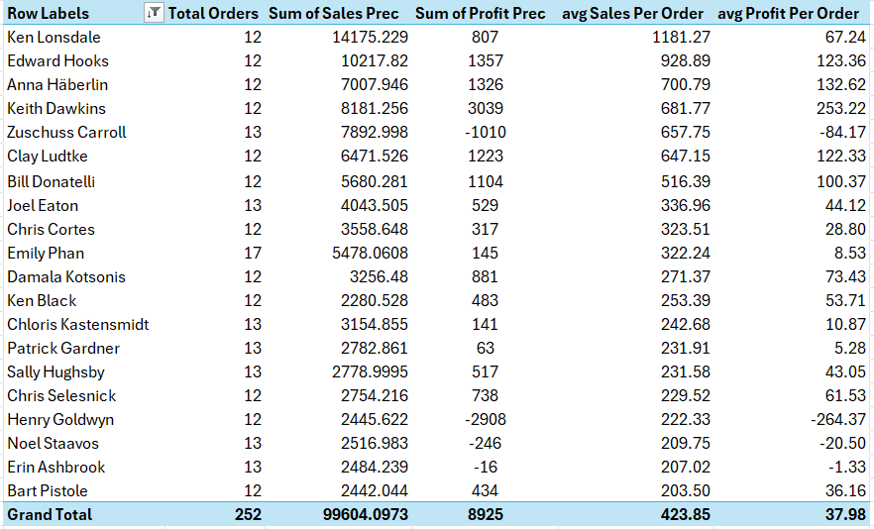

**🕒 Time-Based Analysis**

**16. Are there seasonal patterns in returns, profit, or sales?**

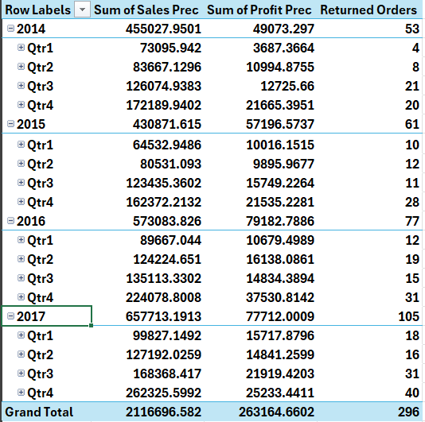

**Finding:**  
Sales and returns peak in Q4, especially in 2017.

**17. How does profit margin change over time (by month/quarter/year)?**

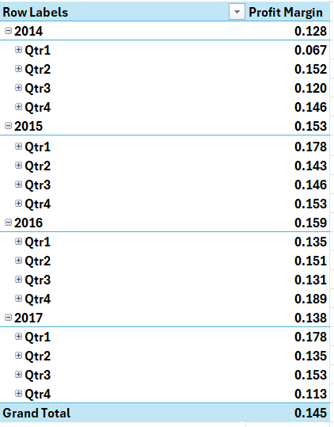

**Finding:**  
Profit margins increase slightly in 2015,2016 and dip in some different quarters due to discounts and returns.

**18. Are returns higher in specific months?**

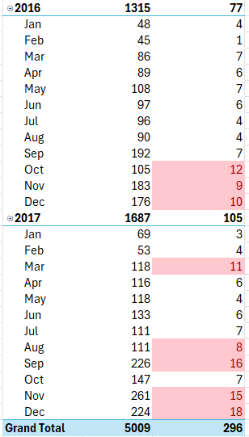

**Finding:**  
Returns are highest in November and December.

**Key Insights**

* Returns and profits show strong seasonal trends.
* Shipping costs significantly affect profitability, particularly for Furniture.
* Technology category has strong revenue but also higher returns.
* Corporate customers are more profitable and have fewer returns.
* Q4 needs better return management strategies.

**Recommendations**

* Tighten return policies during Q4.
* Focus marketing efforts on Corporate customers.
* Negotiate better shipping contracts.
* Analyze Technology product returns for quality improvements.
* Increase monitoring of customer return behavior.